**Page 1**

**Introduction**

Dear Customer!

Thank you for purchasing our C5 Carplay & Android Auto device. Please read this User Manual carefully to learn how to operate the device and ensure optimal performance.

We recommend that vou keep the User Manual for future reference.

1. **Package**

The standard package includes the following items:

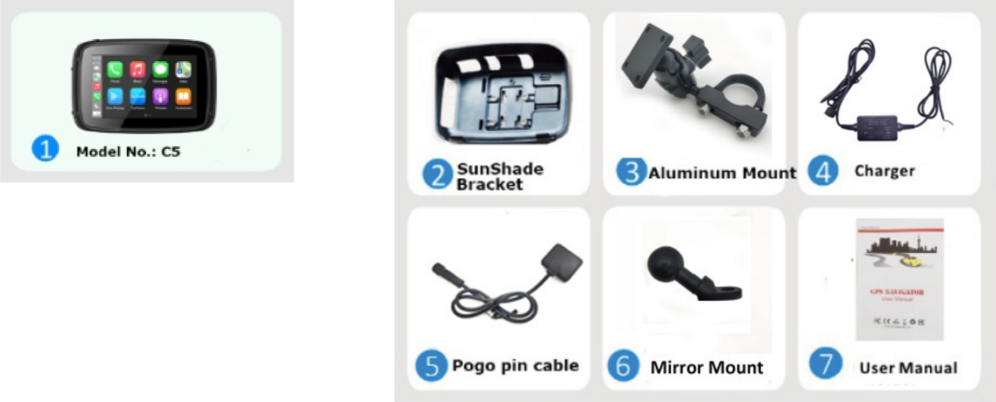

1. **Device layout**

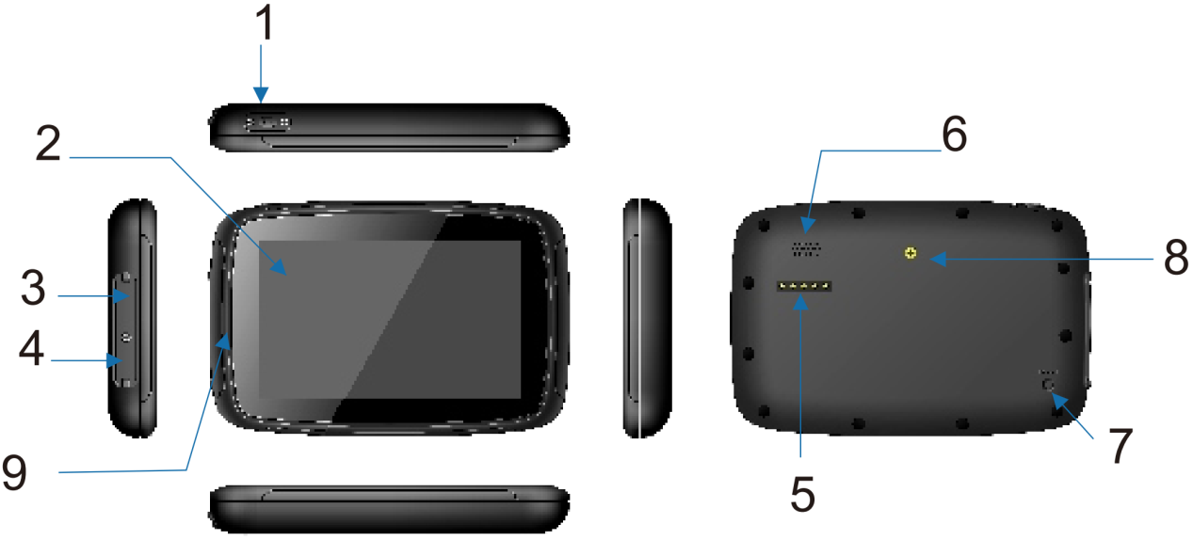

|  |  |
| --- | --- |
| 1. Power button | Turns the device on/off |
| 1. Touch screen | 5’’ TFT touch screen display |
| 1. TF card slot | Supports TF cards up to 64GB |
| 1. Mini USB port | USB client 2.0 |
| 1. Charging port | For connecting the charger |
| 1. Speaker | Provides audio output |
| 1. Reset button | Reset |
| 1. Screw hole | Fix cradle |
| 1. Microphone hole | To record voice |

Installing a TF card

Insert the TF card as shown on the picture

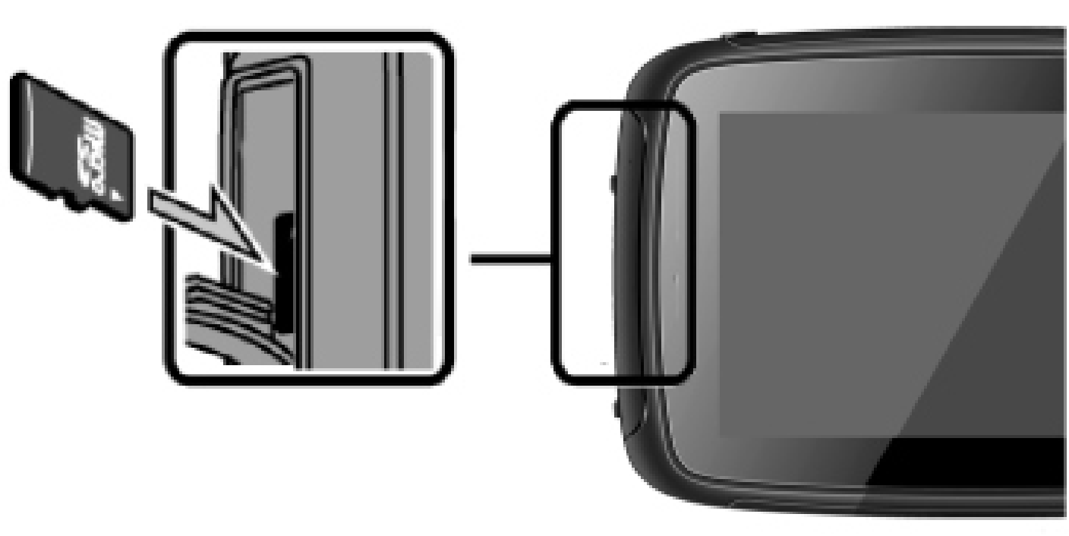



**Page 2**

1. Specifications

|  |  |
| --- | --- |
| Operation system | Linux OS |
| Memory | 2GB Flash |
| LCD display | 5’’ LCD display  Resolution: 800RGB(H)x480(V) |
| Touch screen | Durable high-precision touch screen |
| Mini USB | USB Client 2.0 |
| TF | TF slot |
| Video | 3GP/ASF/AVI/DivX/MKV/MOV/MP4/MPG/TS/VOB/WEBM/M4V/FLV |
| Audio | MP3/MP2/WAV/AAC/AMR/M4A/OGG/APE/FLAC |
| WiFi | 5G |
| Bluetooth | Two channels |
| Charger | 5V/2.5A Input |
| Temperature | Operating Temperature: -20°C to 80°C  Storage Temperature: -20°C to 80°C |
| Working humidity range | 45% to 80%RH |
| Storage humidity range | 30% to 90%RH |
| Atmospheric pressure | 86KPa to 106KPa |

1. **Mounting instructions(Motorcycle):**
   1. Install the device and sunshade

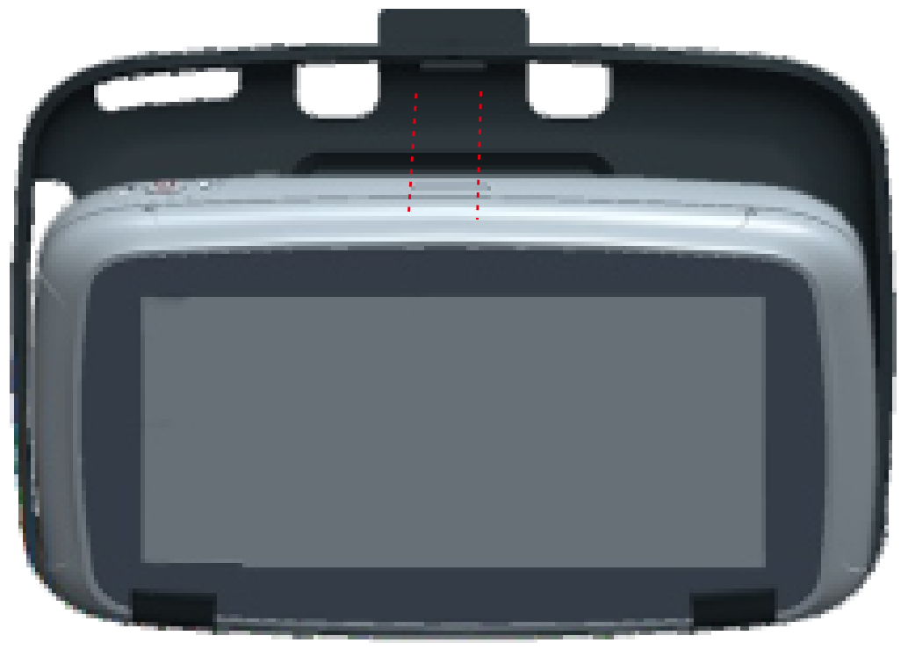 1) Put the device in the sunshade.

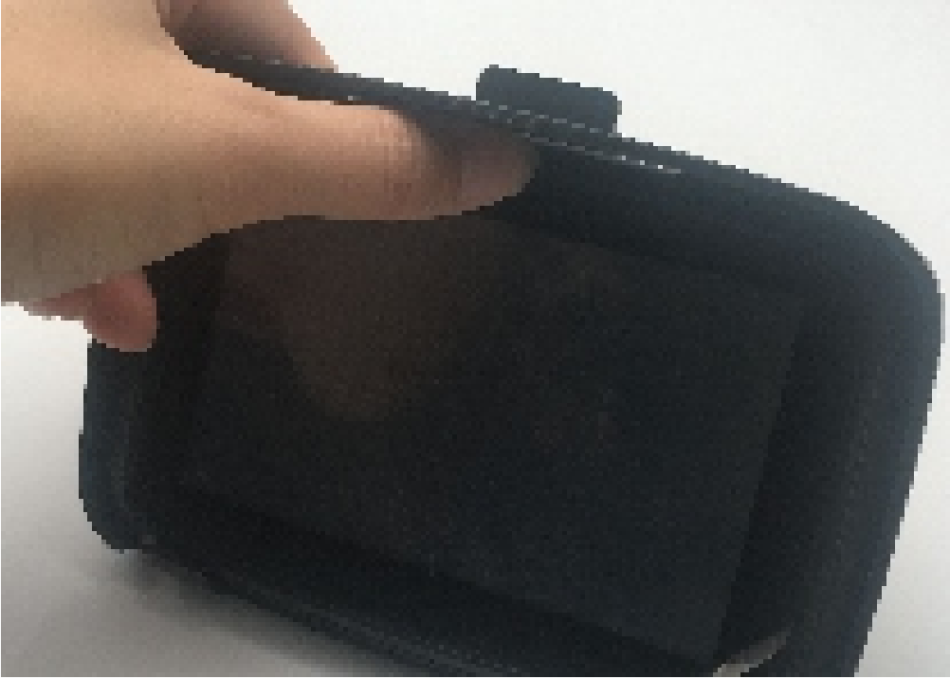 2) Use a thumb to push the top until you heard a sound "click".

How to know if the installation is good.

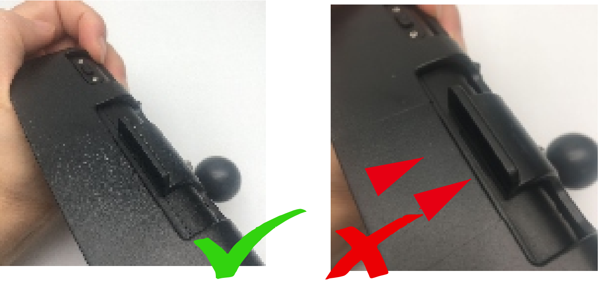

* 1. Installation at the Handlebars:

1. There are several ways to install the bracket as following:

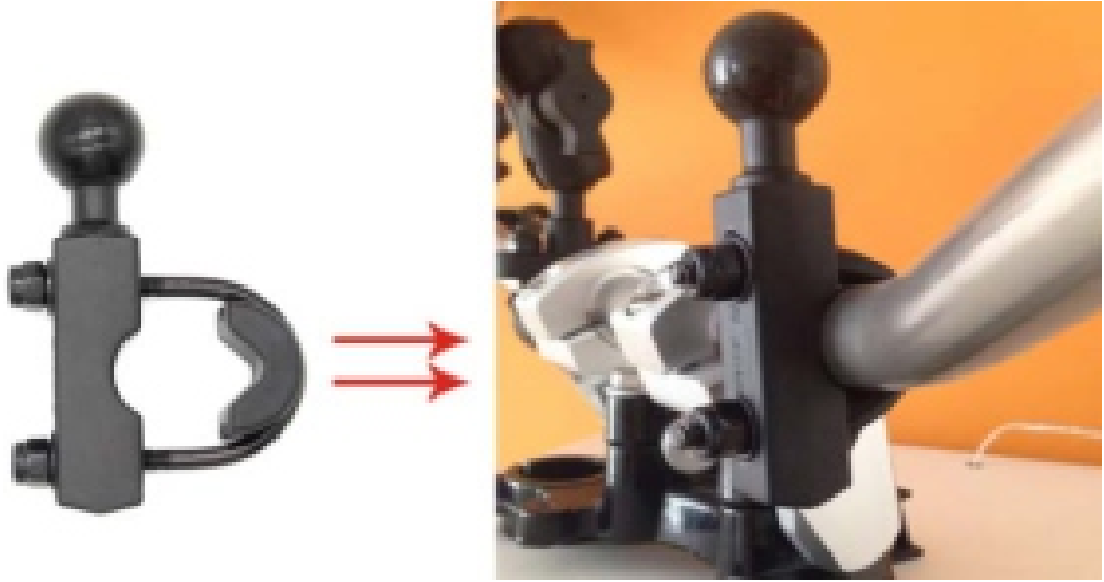

1. Install the device to the cradle, wring the screw behind the mount to fasten the device.

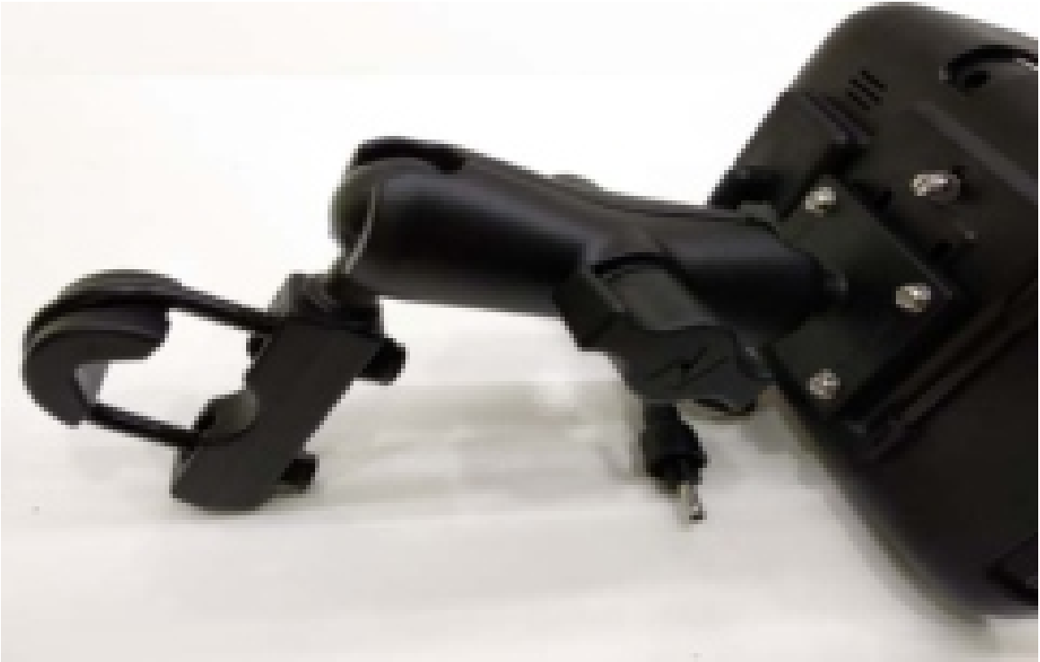

4.3. Connection of the device to the power supply of the motorcycle/car.

4.3.1 Via cigarette lighter

4.3.2 Via motorcycle battery power

1) Connect the red line (+) to ignition switch.

2) Connect the black line (-) to the negative pole.

When you turn on the motorcycle, the device will turn on automatically.

**Page 3**

**5. Power on/off**

5.1. Power on

Plug the chargers, it will automatically power on. Press the button at the top of the device, the device will enter power saving mode. Press it again, the screen will be back.

Please make sure that the device is connected to an external power source.

5.2. Power off

Disconnect the chargers, it will automatically power off

**6. User Interface**

1. Home button: Tap it to return home page

2. Android Auto: Tap it to connect android mobile

3. Apple CarPlay: Tap it to connect iPhone

4. Time and Date: Display current time and date

5. HuaWei HiCar: Tap it to connect HuaWei mobile

6. Bluetooth icon: Show the bluetooth statue

7. Daytime mode or night time mode

8. Speaker: Tap it adjust the volume of speaker

9. SD Card: Tap it view the data of the micro SD

10. Return button: Tap it to return previous page

11. Setting: Tap to enter setting menu

12. Emit BT: Tap to connect bluetooth device

**7. Phone Bluetooth Connection**

1). Tap on Setting->Bluetooth on device and active Bluetooth function on phone.

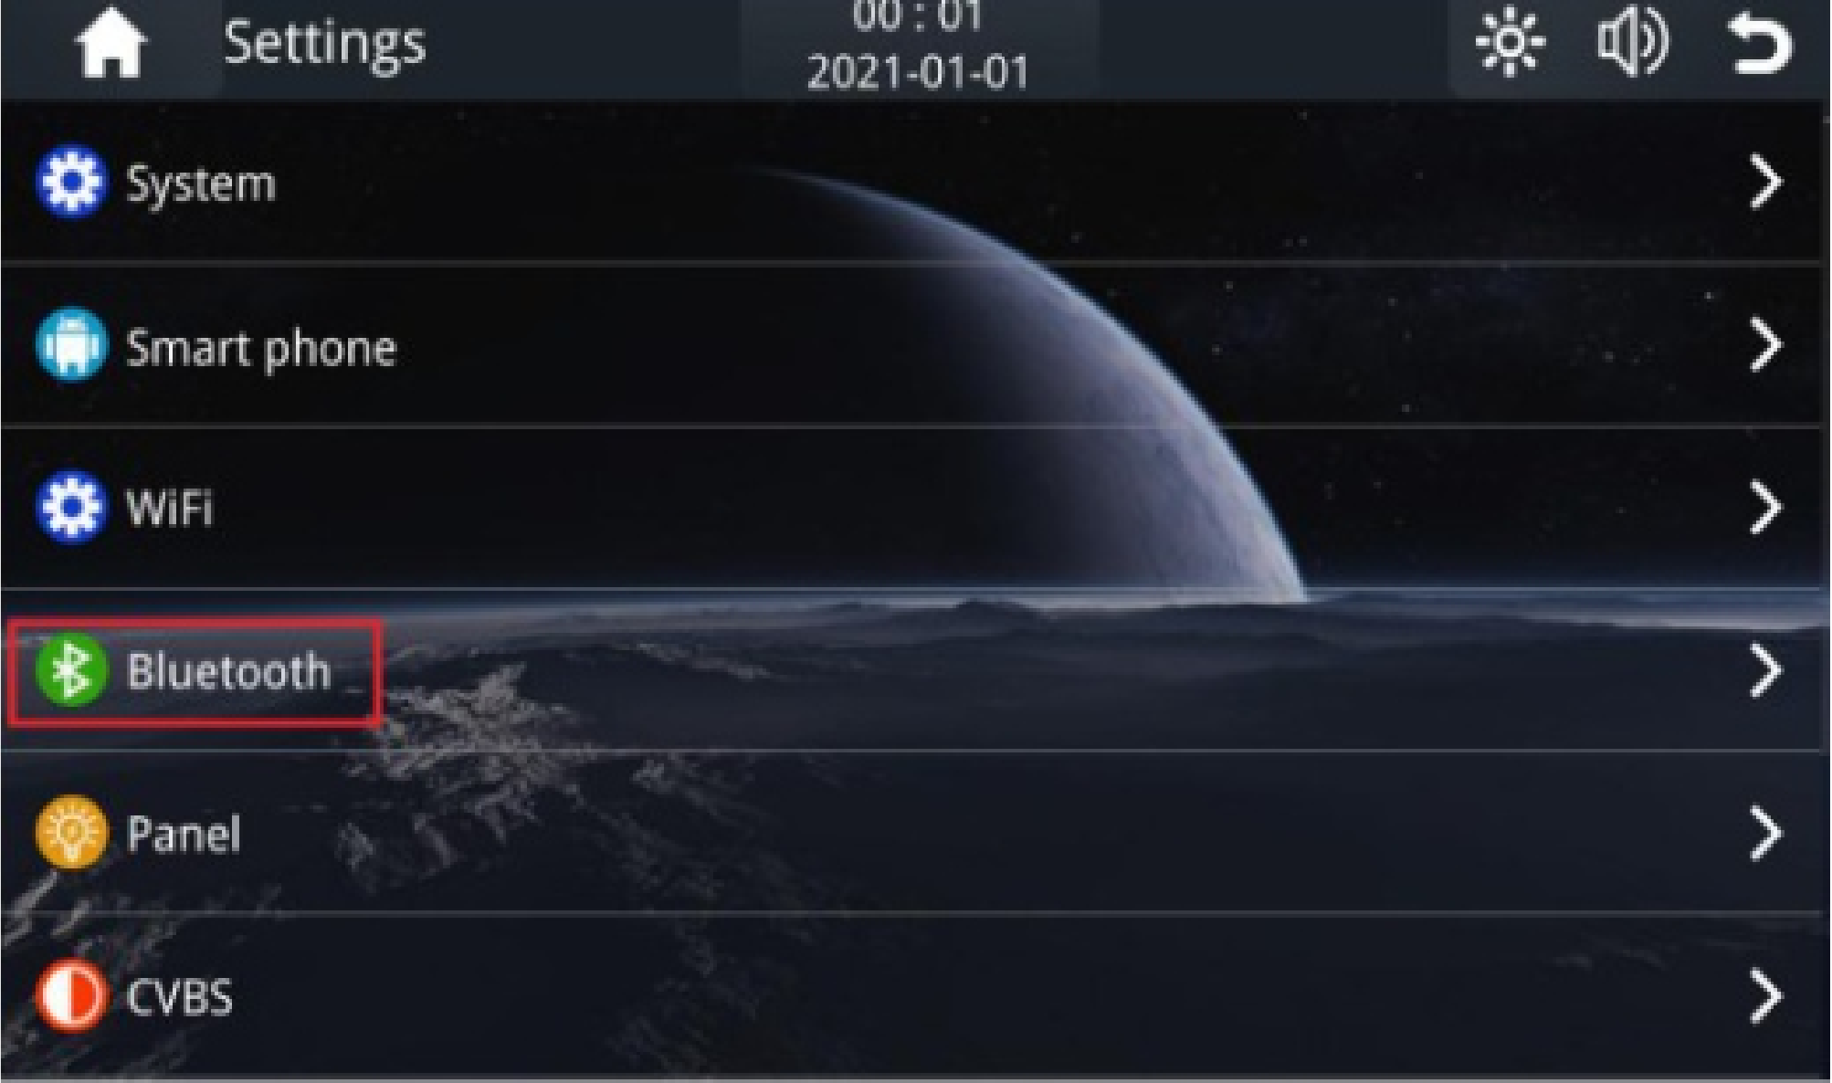

2).The phone will search the device and tap the same bleutooth name device.

lt will pop up “Bluetooth Pairing Request", input the pin code and tap “pair”.

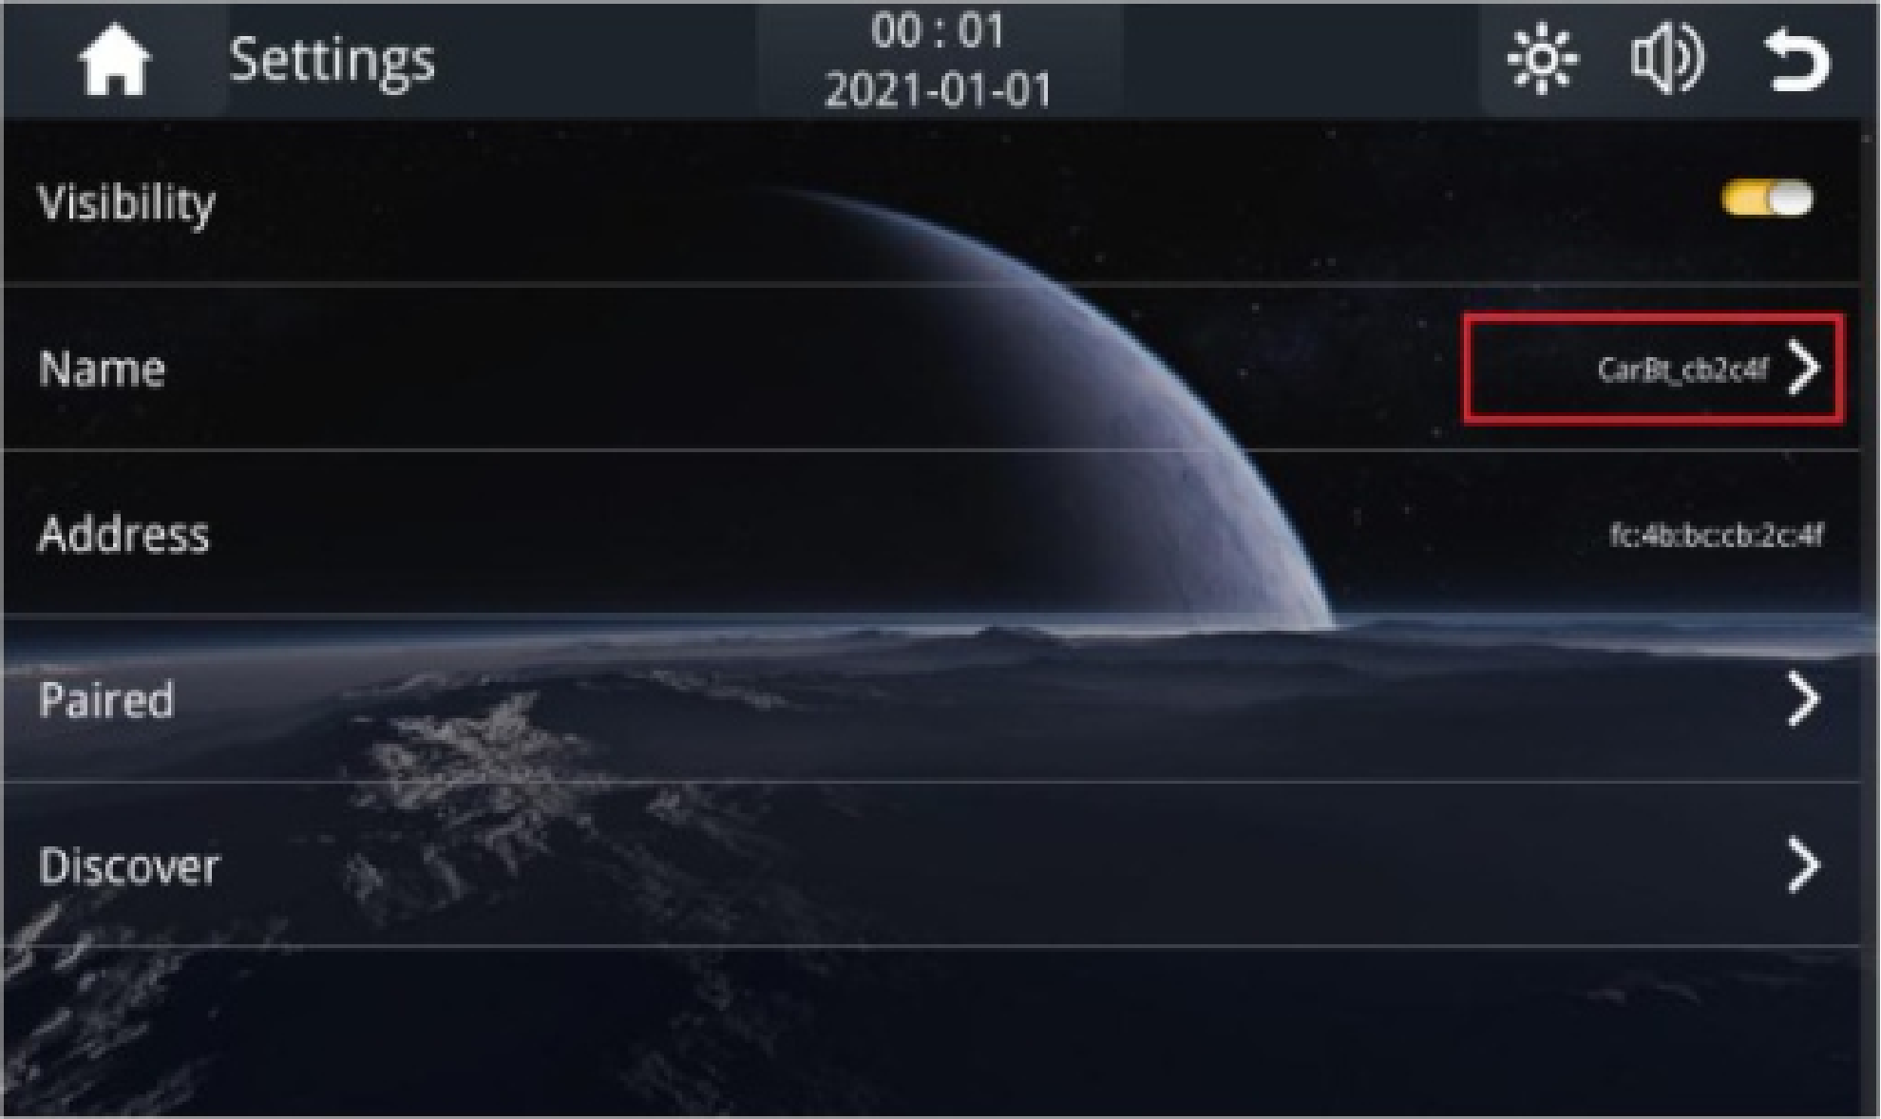

**Page 4**

**8. Wireless CarPlay Connection**

1). Tap the CarPlay icon.

2). If it is the first time to use, please follow the steps as below:

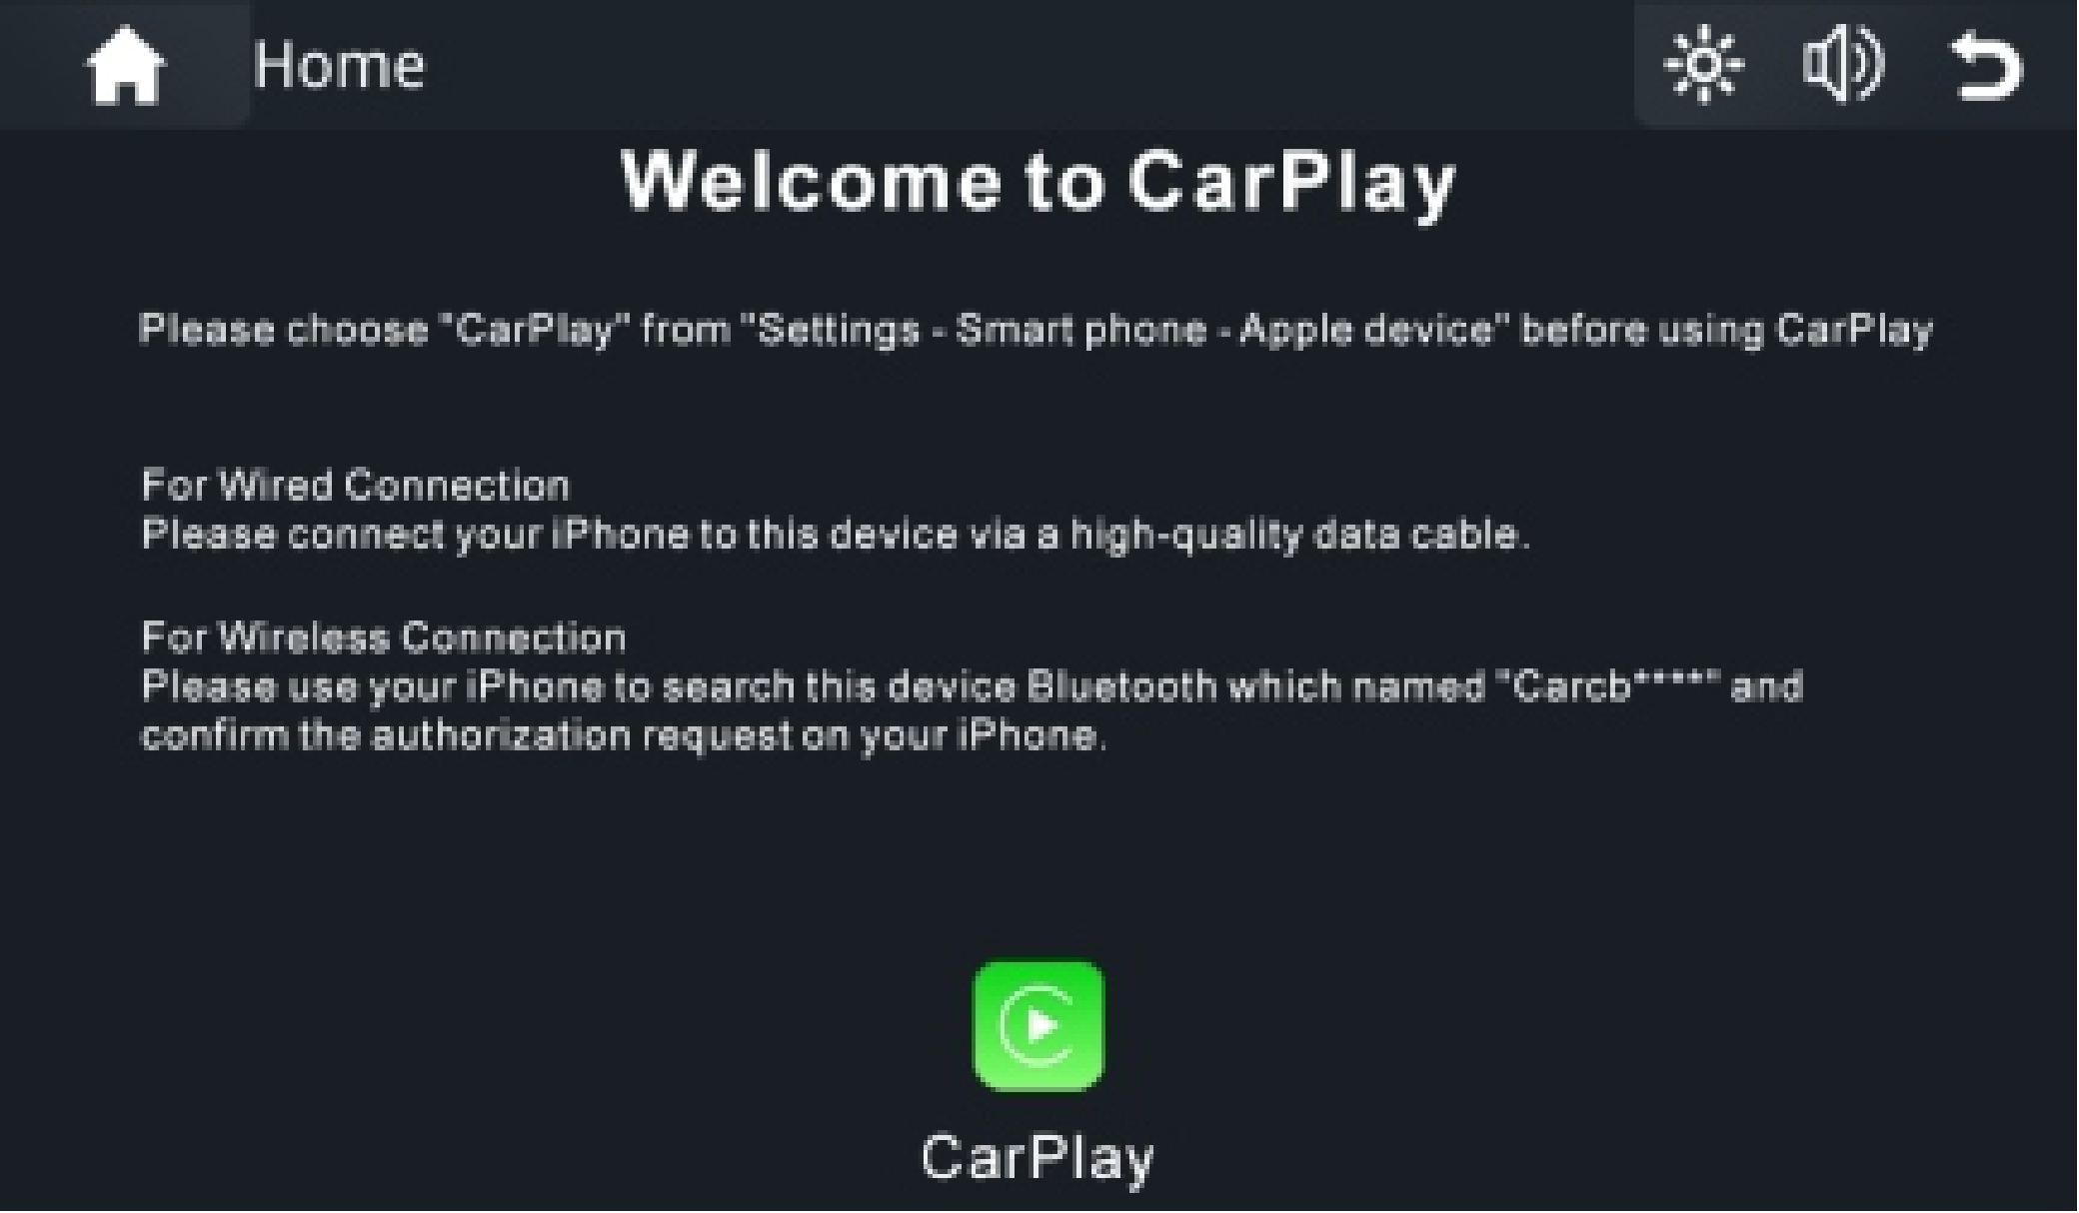

**9. Wireless Android Auto Connection**

1). Tap the Android Auto icon.

2). First time to use, pair the bluetooth between mobile and C5 device.

Note: lf your phone don't have Android Auto, please go to Google play app to install Android Auto.

**10. Wireless HuaWei HiCar Connection (Optional)**

1). Tap the Huawei HiCar icon.

2). First time to use, pair the bluetooth between mobile and C5 device.

**11. Emit Bluetooth Connection**

1). Tap Emit BT icon enter the bluetooth menu.

2). Start the Helmet Bluetooth in pair mode.

3). Active "Search Devices".

4). Tap the helmet bluetooth device name to pair

